Name: Cool, Logan / Nyong, Ndon
NSID: llc242, non877
Project: jEdit
Change Number: 2
Date: April 5, 2013

jEdit Change Request

Change Request:
We ended up changing:
1) The splash screen window - when it loads quickly you see our names
2) Activity Log - add a timestamp
3) Modify the Search - displays the last 5 searches in the window.

Concept Location:
The use of grep help my location of what needed to be changed. I simply looked at what tools surrounded the target change and searched for the term.

Explain the methodology that you have used to locate each concept that was part of your change request.
1) The splash screen was quite easy when it comes to tracking its location. It was a png image so i knew that I could simply search for a splash name located in the place where the pictures were stored. In our case this was the icons folder. After verifying the name, it was easy to once again use grep to search where the filename was being called. A simple change of the picture and Thread.sleep() allowed the updated picture to be seen at a reasonable time.

Use “Unchanged” if the class has no relation to the concept but you have visited it.
Use “Propagating” if you read the source code of the class and it guided you to the location of the concept, but you will not change it.
Use “Changed” if the class will be changed.
In the fifth column, write what you have learned about the class.

Table 1. Splash Screen, About Modifications.
# | File name | Tool used | Located? | Comments
1 | AppearanceOptionPane.java | find/grep | unchanged options | nothing needed, misguide.
2 | SplashScreen.java | find/grep | changed - gui | found where the image was being called.
3 | jedit_gui.props | find/grep | changed home jedit | found interesting how things were stored.
 | AboutDialog.java | find/grep | changed - gui | seemed to be useful for modifications to the speed/

Table 2. TimeStamp.
1 | Log.java | find/grep | changed - util | found right away this was used for the logging
2 | jedit_gui.props | find/grep | changed - home jedit | found this where it configs. no use.

Table 3. Search Modification.

1 | SearchDialog.java | find/grep | changed - home jedit | found the comment
2 | HistoryText.java | find/grep | changed - gui | found the loop for the stored text

Impact Analysis:
Table 2. The list of all the classes visited during impact analysis.
# | Class name | Tool used | Impacted? | Comments
1 | gui - SplashScreen, About | eclipse / grep | AboutDialog - AboutPanel -  HistoryTextField - ActionBar
2 | util - Log | eclipse | loglistmode, LogOutput stream.
3 | jedit | eclipse | AboutPanel,AnimationThread

Learning process: The class diagram containing all the classes that I visited.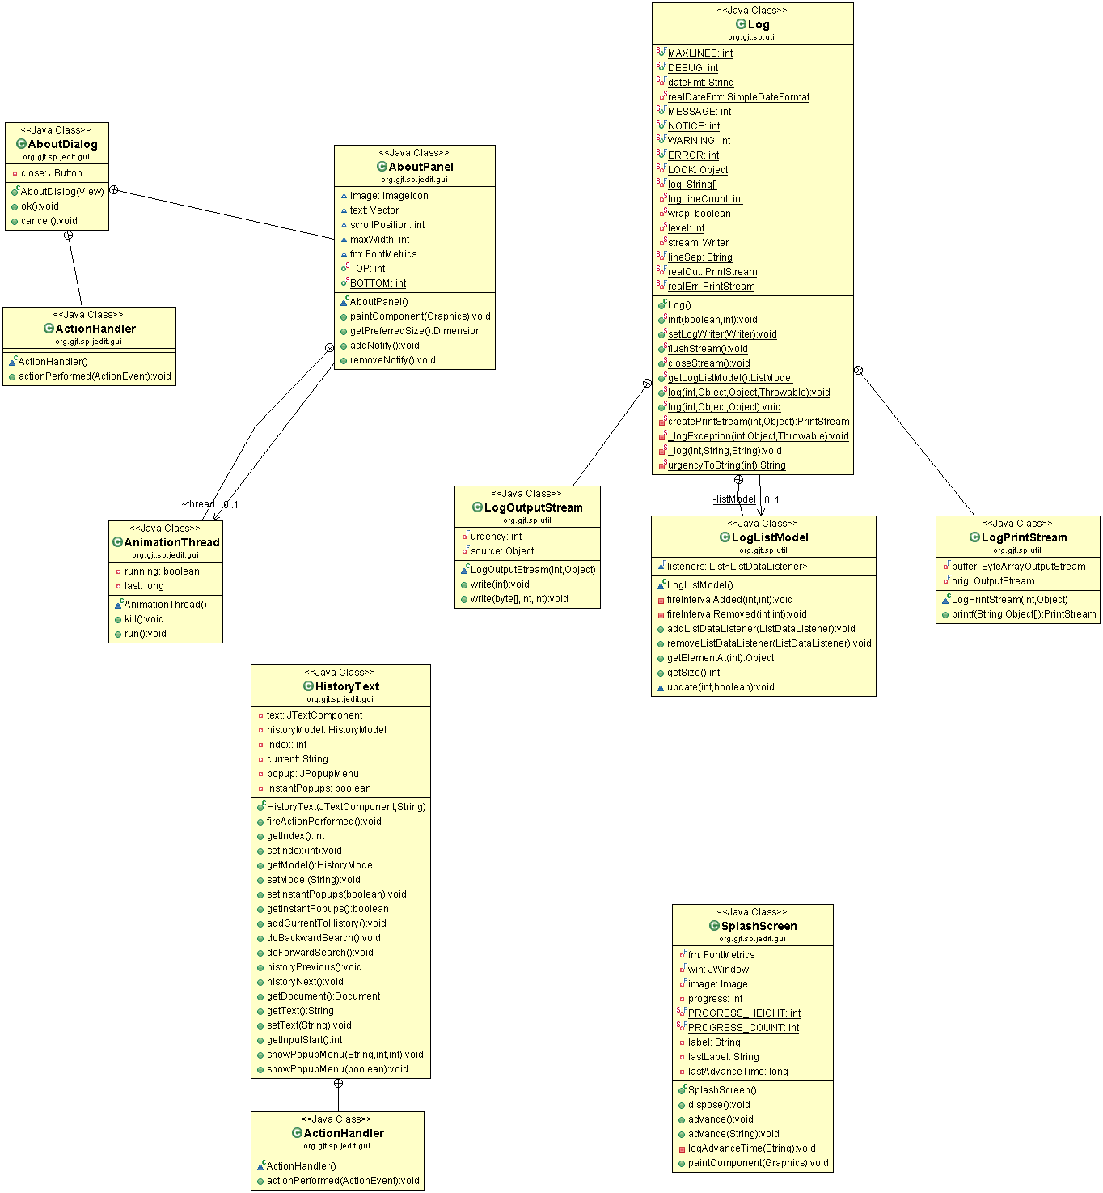

Description of the implementation:
This is shown in the above tables. I made these changes in the way that I did to try to pinpoint the directly what needed to be changed without going through page by page.

Sources:
- OpenSim UML Editor
- jEdit source

